Curriculum Vitae and Learning Plan

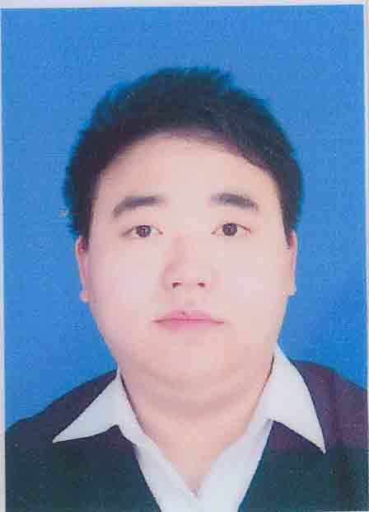 | NAME: Xiang Qian  Gender: Male  Date of Birth：Sept. 16, 1988  Address: Hunan Agricultural University, Furong District, Changsha, Hunan Province, China, 410007  Mobile phone: +8613548754809  E-mail: eric88916@hotmail.com  Citizenship: P.R.CHINA

EDUCATION
Hunan Agricultural University, Spet, 2011-present, a candidate for master degree of engineering, Changsha, Hunan, China.
Major | Environmental Science
Subject Majors | Environmental Pollution Chemistry and Toxicology
Environmental Monitoring Technology
Pollution Ecology and Technology
Supervisors (tutor):
Prof. Tang Qiyuan, doctoral mentor, College of Agriculture, Hunan Agricultural University, Changsha, Hunan, China.cntqy@aliyun.com; Prof. Zhang Yuzhu, senior research, deputy director, Hunan Rice Research Institute, Hunan Academy of Agricultural Sciences, Changsha, Hunan, China. yuzhuzhang@hotmail.com

Hunan Agricultural University, Spet, 2007-June, 2011, a bachelor degree of engineering.
Major | Environmental Science
Changsha Yali Middle School, Spet, 2004-June, 2007, senior high school
Changsha Yali Middle School, Spet, 2001-June, 2004, junior high school

SKILLS
▪ CET4 580 (College English Test)
▪ CET6 538 (College English Test)
▪ CET-SET A Level (college English Test-Speaking English Test)
▪ TOEFL 85 (Test of English as a Foreign Language）Aug 2010
▪ PCRE grade 2 (Provincial Computer Rank Examination)

RESEARCH AREA (examples)
My undergraduate thesis talks about the effect on the absorption of arsenic from water by MnO2 nano-needles. In my first year of postgraduate student career, I’m mainly focousing on the area of pesticide residues, which is the advanced research area in Hunan Agricultural University as well as in Hunan province. There are only three professors that focous on the area of pesticide residues in Hunan province and my outstanding tutor Dr. Gong daoxin is the pioneer of them. I have finished one project about the effect of 80% of pyrimethanil on cucumbers this semester. Our pesticide residues laboratory has been equiped with HP 1100 series HPLC, Agilent Technologies 1260 infinity HPLC and Agilent Technologies 7890A GC system plus Agilent Technologies 5975c inert XL MSD with Triple-Axis Detector, which are some of leading instruments in our university.

My name is He Yang, a second-year postgraduate student from Hunan Agricultural University. It is an honor for me to get the chance to be an exchange student in your distinguished school, which may be a contribution to my career and may enrich my life experience. My undergraduate major in Hunan Agricultural University is agronomy, and I have received my bachelor's degree in June, 2013., I completed my undergraduate thesis under the guidance of Prof. Liu Zhongsong, who is a professor in cultivation and breeding of Brassica, In this period, I have studied some basic theory about agronomy and cultivation of oilseed rape. I'm now engaging in my master degree in cultivation and farming system, my major reseach is high-yielding and ecological cultivation technology for rice.
In southern China, rice-rape rotation is a general system of cultivation, and cultivation mainly rely on labor force but not agricultural machinery. The expansion of cities has led to a labor shortage for agricultural production in rural areas and farmers no longer work all the year, most of them just cultivating double-season rice or even single-season rice, but not farming in winter. Under such a background, "Collaborative Innovation Center for Multiple Cropping System and Modern Production in Sourthern Paddy Crop Area" is established by Hunan Agricultural University, Hunan Academy of Agricultural Sciences, Institute of Subtropical Agricultural, The Chinese Academy of Sciences and other several institutes. The center aim at studying multiple cropping system(main research interests is rice-rape rotation) and modern production(main research interests is agronomic techniques for mechanical production). As one of student of the center, if possible I'd like to learn the condition of this two aspects and get to kown the agriculture, especially the cultivation condition in Poland, I expect to follow a tutor guiding my study in WUELS.
I have now completed credits that required for a master degree in HAU, however, in order to learn more about my major field and get more experience for future career, I am willing to take one or more courses in WUELS.
I am eagerly looking forward the life in Poland and sincerely hope to start my learning in WUELS.
Best Regards,
He Yang

PLAN PROPOSITION
- Know the Laboratory animal science of Wroclaw University of Environmental and Life Science.
- Take as 1-2 specialized courses of master (doctoral) degree.
- Study in your ordered research team.
- Do a experiment and hope to publish an article.

