Hunan Agricultural University
International Student Admission Brochure

I. Eligibility
1. Educational Background and Age
Applicants for language program and bachelor's program must hold high school certificate or equivalent qualifications. Applicant must be 18 years old or above, and in principle, under 25 years old.
Applicants for master's program must hold bachelor's degree or equivalent qualifications.
In principle, applicants should be under 35 years old.
Applicants for doctoral degree must hold master's degree or equivalent qualifications.
In principle, applicants should be under 40 years old.
2. Language Proficiency
Applicants for programs taught in English must possess an IELTS score of 5.5 or above, or a TOEFL score of 65 or above. If applicants have corresponding courses taught in English during their past study, they can be exempt from language proficiency (certificate of English-taught program is required).
3. Academic Performance
The average score of applicants' previous program should reach 70 points or above (on a 100-point scale), or GPA 3.0 or above (on a 4-point scale).
4. Background Requirement
Applicants are not required to meet all background requirements. However, if applicants can meet at least one of the background requirements or more, it will be preferable during admission.
Applicants should currently be employed;
Applicants should be working in government departments or public institutions;
Applicants should have work experience in government departments, public institutions, or enterprises;
Applicants should be able to afford their own life expenses during their study in China.
II. Deadline for Autumn Application
July 30, 2025
III. Documents
1. Passport (valid for one year or more);
2. Application Form of Hunan Agricultural University
3. A self-introduction video less than one minute, in mp4 format, with a file size no larger than 40 MB.
4. Highest academic qualification (notarized documents in Chinese/English). If an applicant is a recent graduate, he/she must submit a pre-graduation certificate issued by their current school.
5. Transcript of highest academic qualification (notarized documents in Chinese/English)
6. Language proficiency (HSK/IELTS/TOEFL or others)
7. Physical Examination Record for Foreigner Applicants should strictly follow the requirements of the Physical Examination Record and fill in the form in Chinese or English. The record must be completed, attached with stamped personal photos, as well as signatures and stamping by doctors and hospitals. If the abovementioned items were missed, the record should be invalid.
8. A no criminal record certificate issued by local public security organ
9. A study plan in China （no less than 800 words for bachelor's program and 1000 words for master's program)
10. Two recommendation letters from professors or associate professors (this requirement is for master's program)
11. Personal resume, published papers, or other supporting documents (not mandatory)
IV. Application
Please forward the abovementioned documents to the International Exchange and Cooperation Division of Hunan Agricultural University via email. Please send your application to Hunau@hunau.edu.cn.
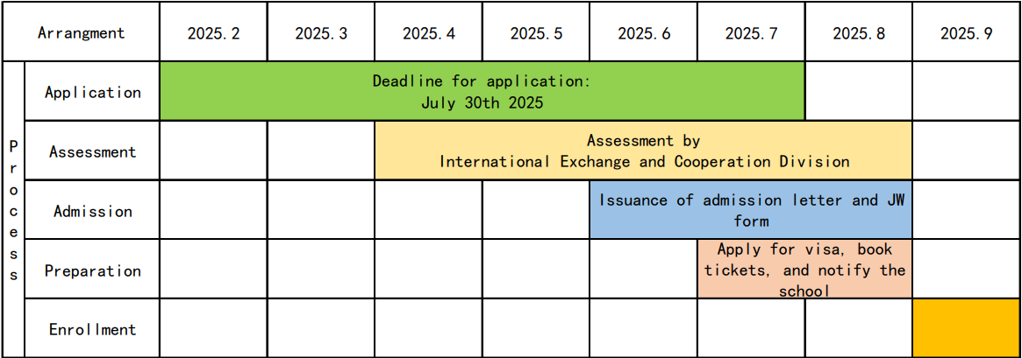
V. Admission Arrangement
VI. Others
1. Consultation: Admission hotline: (+86)731-84618060; admission email: Hunau@hunau.edu.cn.
2. Accommodation arrangements: Upon admission, HUNAU will arrange on-campus accommodations in standard double-rooms.
3. Airport pick-up service: HUNAU provide one free airport pick-up service on a designated date before the semester (booking required).
4. Entrance Education: After registration, HUNAU will organize entrance education for freshmen, covering laws and regulations, university disciplines, as well as cultural adaptation, etc.
Admission documents:
1. Fees and Scholarships for International Students of Hunan Agricultural University
2. Physical Examination Record for Foreigner
3. Application Form of Hunan Agricultural University

Hunan Agricultural University
International Exchange and Cooperation Division
March 5, 2025

